Hello Parkland Families,
The following is information about what your child will be doing for the next few days at school. A separate Gradual Entry & Welcoming Conversation plan has been sent out to families who have students entering Kindergarten at Parkland as their schedule will be somewhat different.

Please be aware that we try to be as paperless as possible so all future communication will be posted on our website and an email will be sent to alert you that new information has been posted. Unless you inform us that you need paper copies sent home no other paper notices will be sent home after this one. If email and web communication will not work for you please contact us as soon as possible so we know to send home print copies with your child.

Wednesday, September 9 – Friday, September 12
In the time prior to our school organization being finalized all students will be meeting in Grade Groups. We have set up meeting places on the playground to simplify the drop-off and pick-up of students. Please see the map below so you know where your child will meet with his or her grade grouping. Your child’s teacher has gone over this with their classes during the meeting today to make sure they are all aware of what is expected.

We have a number of activities planned for the first week of school to ensure that the time prior to being placed in their new classroom groupings is well used. We will be coming together frequently as a school community for ‘school meetings’ to welcome new students and teachers into our community, and to set school-wide expectations. During the week these school-wide activities will include:
- Restitution – Basic Needs – students will be involved in learning about people’s basic needs and in activities to think through how each of us meet these needs in different ways. They will be involved in conversations in grade-alike groupings and in multi-age / family groupings (similar to the groups we used for Sports Day last June).
  - Wednesday – Survival
  - Thursday – Love and Belonging
  - Friday – Fun
This conversation will continue the following week when they are in their new classrooms with the other two basic needs – Power and Freedom. Be sure to check-in with your child to find out what they learned and how they meet their personal needs in these areas.
- School-wide art activity – our students will work in multi-age groupings in a project to illustrate how they meet their basic needs
- Playground Games – learning new games to play during recess and lunch

School Supplies
Starting on Tuesday, please have your child bring a pencil case with a few basic supplies for use this week. Please include a pencil, eraser, crayons, scissors, and a glue stick. Please keep all other supplies at home until students are in their permanent placement for the year.

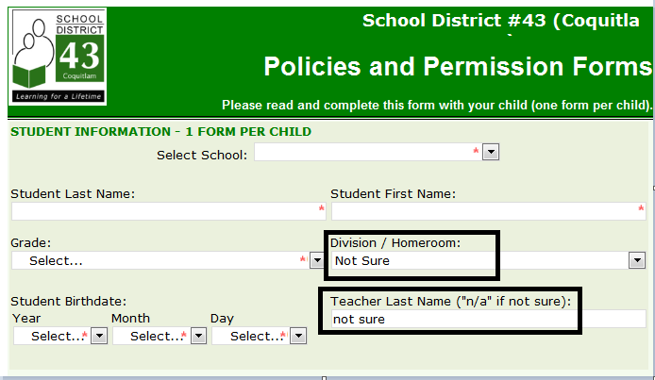
Eforms
The school forms are now available on the School website (www.sd43.bc.ca/Parkland). Please fill these out as soon as possible. The forms ask for division and teacher name – in these fields please select “not sure” and we will add that information later.

Please make sure to complete these as soon as possible as there are activities your child will not have permission to participate in at school until they are complete. These activities include:
- Using the Internet at school
- Neighborhood walks (For intermediate students this includes going to Como Lake for the Terry Fox Run)

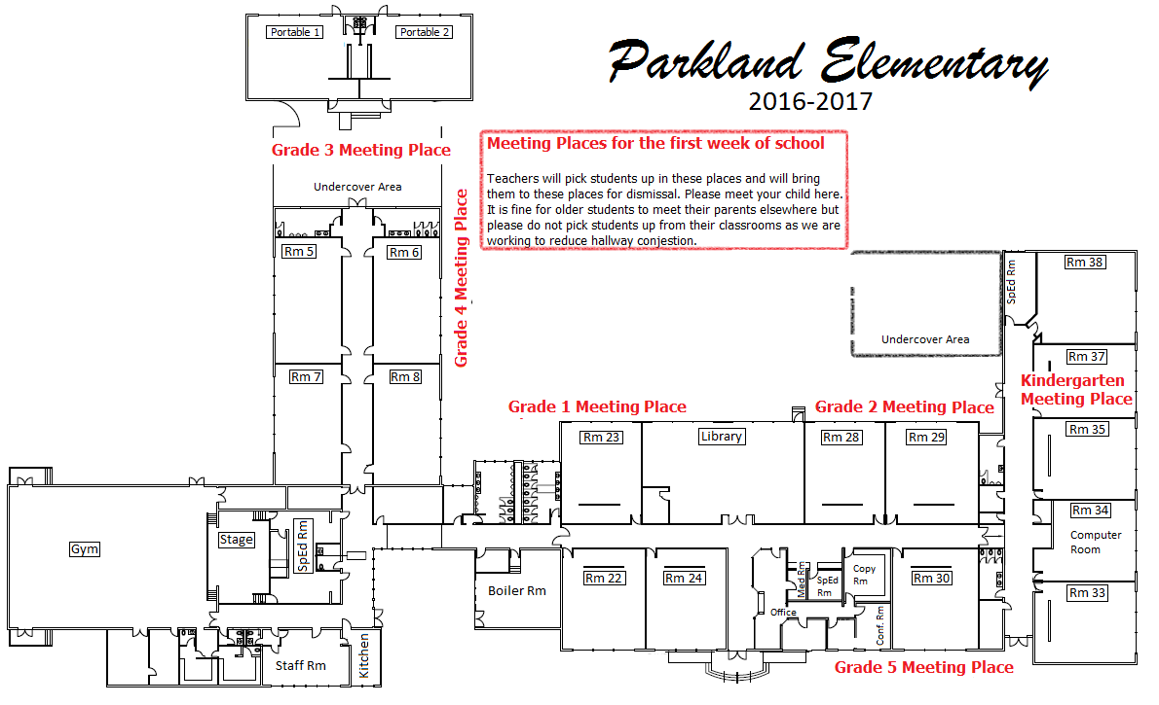

As always, if you have questions about things that are going on at school for your child let me know – please send me an email, call, or set up a meeting.

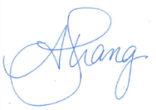
Sincerely,
Anita Strang
astrang@sd43.bc.ca
Principal, Parkland Elementary

